Software Requirements

Specification

for

<Project>

Version 1.0 approved

Prepared by <author>

<organization>

<date created>

Software Requirements

Specification

for

<Project>

Version 1.0 approved

Prepared by <author>

<organization>

<date created>

Software Requirements

Specification

for

<Project>

Version 1.0 approved

Prepared by <author>

<organization>

<date created>

Software Requirements

Specification

for

<Project>

Version 1.0 approved

Prepared by <author>

<organization>

<date created>

Software Requirements

Specification

for

<Project>

Version 1.0 approved

Prepared by <author>

<organization>

<date created>

**Software Requirements Specifications**

**Company Directory**

Gergo Kondor

20/09/2021

1. **INTRODUCTION**

This document is a response to the brief submitted by Paddy Evans. It presents a high level view of the main system functionality along with some sample screen layouts to facilitate better understanding of the proposed solution. Acceptance of this document by the sponsor will initiate a formal system development project that will be designed and built according to prevailing company standards.

1. **PRODUCT DECRIPTION** 
   1. **SCOPE**

The product is intended to be a standalone, single page application that is designed to be mobile first, but work equally as well on desktops. The application will allow the user to manipulate the database using a simple interface which connects front-end components to server side endpoints to achieve this result. An example of the typical functionality is shown in the diagram below:

Depending on selected button in modal, code runs SQL query to database through PHP backend

Button opens a modal using JavaScript/jQuery

User clicks a particular button or searches to find a result

HTML page outputs organised result

* 1. **PRODUCT FEATURES**

The application will be developed using the following:

* HTML/CSS/JavaScript (Bootstrap framework)
* PHP (JSON data interchange)
* MariaDB (Create, Read, Edit and Delete).

The wireframe model below demonstrates the proposed layout and functionality:

As understood from the product brief, the goal of this site is to allow easy to understand access and editing of the employee database. So, the main view of the page would list all employees in the database, and their most relevant information, which can be used to sort and filter employee data. Each line displays the name, department and location of each employee, plus date of birth (if available) which should help identifying employees with more common names. Any other data available on employees can be accessed by clicking/tapping the details icon.

**NEM VEGLEGES DESIGN**

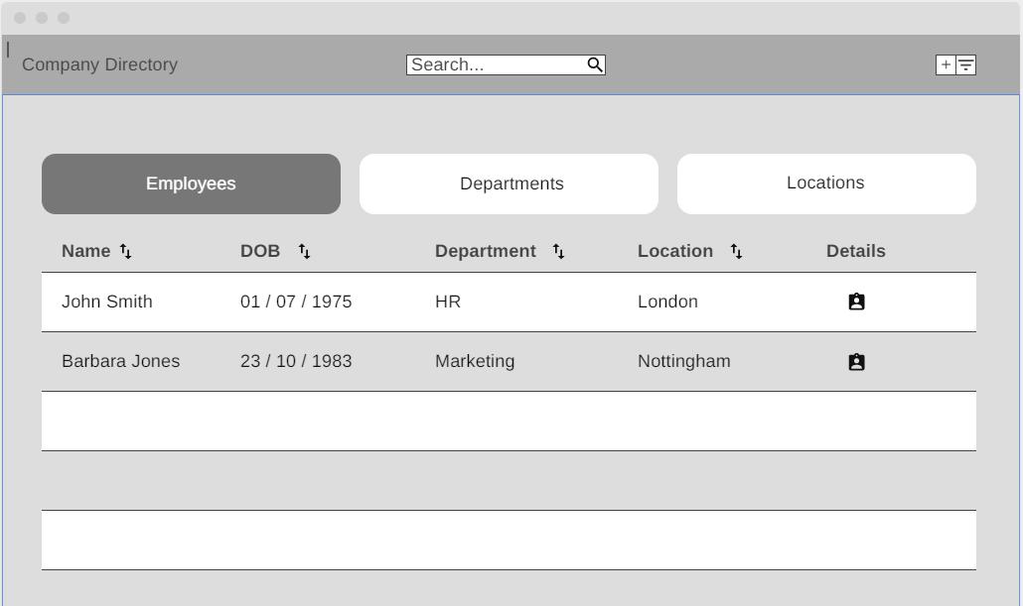

There are two more views to be able to list and maintain department and location lists. These views will be similarly structured as the first one, but with less data columns.

**Modals:**

There are different functions on the page which can be accessed through different buttons and will open as modals.

**Features**:

* Add: add new employees, departments, and locations via the *plus* (+) button of each screen view (Employees, Departments, Locations).
* Filter: where the user can select which departments/locations to show. Depending on the data available in the SQL database, more filter criteria can be added if necessary
* Search: search will be conducted in all visible data fields
* Sort: by clicking the sort button in any column, the list will be reordered based on that column in alphabetical order and reverse if clicked again
* Details: the details button which is available in Employees, Departments and Location views displays all of the stored data about that item
* Edit: it is possible to edit employees, departments, and locations via the *Edit* button which is available in the Details modal, after clicking the *Edit* button it changes to a *Save* button and allows editing of the stored data
* Delete: it is possible to delete employees, departments, and locations via the *Delete* button which is available in the Details modal, after clicking the *Delete* button, a new modal pops up to confirm deletion

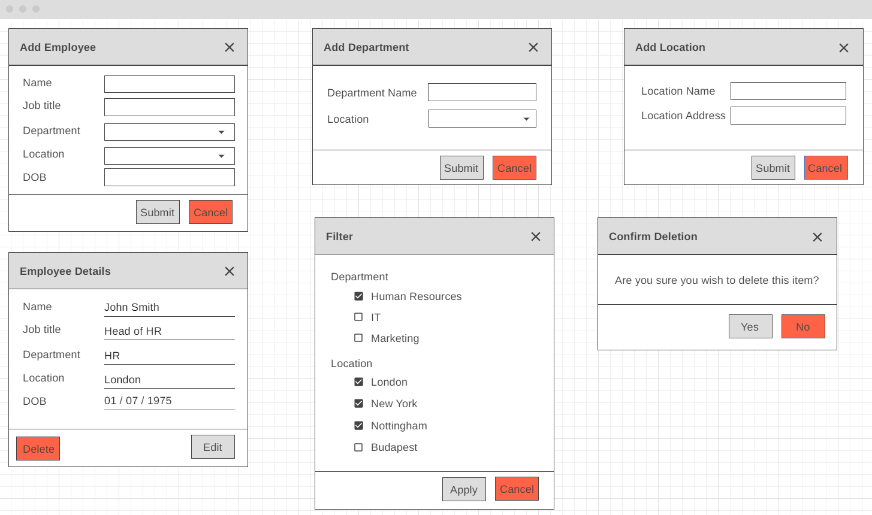**NEM VEGLEGES DESIGN**

Acceptance of this document will initiate the development of the system.

Sign off: Paddy Evans

............................................................................... Date